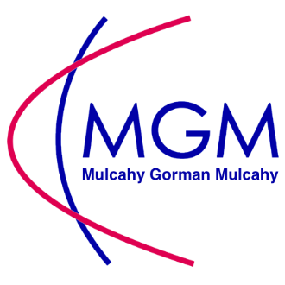
Minimum Wage 2020

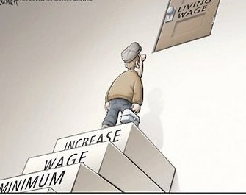

Minimum Wage
Since 1st February 2020, the minimum wage rate for adults is €10.10 per hour.
Minimum Wage applies to all employees, including full-time, part-time, temporary and casual employees, the only exceptions are for close relatives of employers and apprentices under the Industrial Training Act 1967.
The new rates are listed below:

- Experienced Adult Worker = €10.10
- Under the age of 18 = €7.70

- In the first year after the date of first employment over the age 18* = €8.08
- In the second year after the date of first employment over age 18* = €9.09

* Employment experience prior to age 18 is not taken into account for these rates.

70/71 O'Connell Street, Limerick Tel: (061) 413 777 Email: info@mulcahygormanmulcahy.com

